Mental Health Matters: Walking back to Happiness?
Would you like to go for a walk? Walking isn’t easy for all of us but is a very worthwhile and available activity that some people tend to overlook.
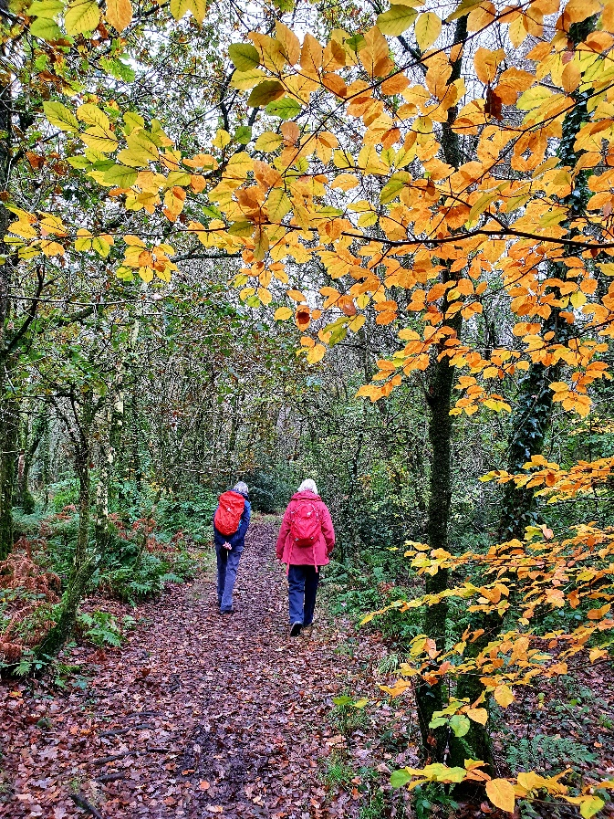
Dog-walkers need to be out exercising their pets as often as is necessary so are having the double benefit of their animal’s company whilst walking in the fresh air. This also gives them the opportunity for social interaction with other dog-walkers. Another great benefit!
We all know that the current situation is causing lack of companionship. You don’t have to have a dog to go out for a walk but, if you feel uncertain about walking alone, perhaps a friend or neighbour might have a dog that would welcome an extra outdoor session. You may then meet other local residents in passing.
Alternatively, how about asking a friend or neighbour if they would like to join you on a walk. We can walk with another person outside our household and talking whilst you walk can be so good for the spirits, especially at the moment.
Our Move it or Lose it classes have had to be suspended until we are allowed to resume them so for me walking is one great way to keep moving!
You may have noticed on our local Facebook page that I am happy to accompany people on a one-to-one walk where you can discover footpaths around Bradninch that you may not have previously known. Just send me a message if you would like to do such a walk. They can vary in distance and time to suit the individual. You may catch the bug for walking once you’ve found some new routes to explore.
Remember to close any gates that you open on your walk, pick up your dog’s poo (and deposit in a bin) and take the opportunity to say hello to someone you don’t yet know. There are new friends waiting to be met just around the corner!
Please keep safe and well.
Sue Jackson
Move it or Lose it! Culm Valley
sue.jackson@moveitorloseit.co.uk
Ps. Move it or Lose it classes are resuming from Dec 8th and do note that it’s permissible to walk in groups of up to 6 from different households.
Pps. BradTog are currently in discussion with Sue and David Kennedy to consider ways of making it easier to get out and about on walks and we may be able to develop a guide to local walks … watch this space!

All good wishes
Glenn, Kate and Sophie
For BradTog MHM
Ps. Do let us know if you have suggestions or offers to make for future postings

