Volunteer Newsletter 5 1st Feb 2021

Hello,

Almost a year ago we started to get together. Since then, a great deal has been happening around Coronavirus, and still it goes on.

Many people have given time, effort, energy and hope to their fellow townsfolk, and the steering group at BradTog have tried to keep a momentum to this. As an admittedly self-appointed group, we remain aware that without people with ideas, the volunteers and especially the co-ordinators there would be nothing to steer, so thank-you for your efforts and indulgence.

We have long wanted to arrange a get together, so we can meet, say hello and exchange ideas, but this seems some way away. We remain, a pretty large group of people who would probably not recognise each other!

Rather than wait for that elusive meeting-up time most of the steering group have evolved into being the Directors of a (non-profit-making) Community Interest Company called Bradninch Together CIC and our registration has recently been completed. This gives us a constitution and a way of being accountable for the various monies that we are administering.

We have some ideas about what BradTog could evolve into in the future, creating a space for new ideas to develop in. We’ll be clearer about that offer soon, and we will be publishing information about the organisation on the website.

For now we’re pleased to report a growing association with Bradninch Town Council as well as with other local organisations old and new, and below is a summary of news.

Volunteer service
We have remained active and at a lower volume than in the first Lockdown, with over 30 acts of kindness undertaken in January. We put this down to friends becoming more active, people not shielding so actively and people insisting on being independent! This is good news and still it remains the case that our co-ordinated network (You!) remains ready and happy to provide help where it’s needed.

Here’s what we did in 2020:

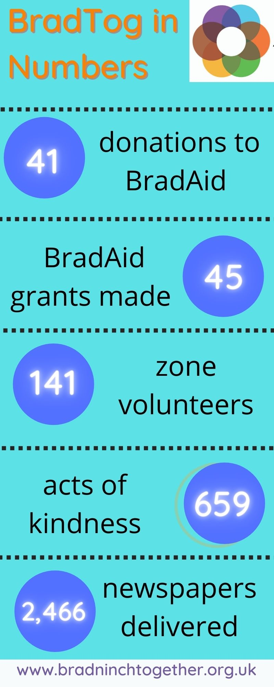

Online Events Night
Staying in is the new going out…but 10 months in even Netflix is losing its appeal!
We’re pulling together a programme of online community event nights, creating opportunities to connect, learn, socialise and simply have some fun during this difficult time.
An Impromptu Christmas Quiz organised by Sophie, was very successful and had people rushing round their houses as well as their memories to find answers.

We call on anyone, individuals, groups or Bradninch organisations, who might be interested in contributing to the programme in some way. It could be a performance, talk, sharing a skill, quiz night, karaoke session…anything that can work via Zoom. You might want to fill a short slot in a wider programme, host an entire evening or anything in-between. BradTog will coordinate and publicise the programme and arrange the online platform.
If you’re interested in taking part, email Kate at: website@bradninchtogether.org.uk

The next events are:
10th Feb 7pm Brush up your French speaking and French wine drinking.. simultaneously…
13th Feb 4pm Family Quiz
17th Feb 7pm Healthy Home Office Osteo
27th Feb 7pm Bradninch Walks

More information, including how to sign up and get Zoom access are about to appear on www.bradninchtogether.org.uk and on a lamppost near you.

Mental Health Matters:
A local group is growing, to pay attention to this important topic. Regular Facebook postings are being supplemented by the development of a local interest group.

Mental health matters to us all and like physical and social health is simply part of life which we seek to care for. The need for this has become all the more obvious since our lives have been so changed by the difficulties associated with Covid.

Although it’s something we all share as part of our quality of life, we live in a culture where it’s not easy to speak about it or seek help when we need to. BradTog developed The ‘Mental Health Matters’ interest group as a way of inviting people to join a group aiming to share that interest and a hope to cultivate care, understanding and confidence around mental health concerns in our Town.

We aim to do this by seeking to support one another, promoting care, kindness and friendship, sharing information and understanding, signposting links to available services and putting on courses and training – when we can.

Over the last 3 months the group has gradually grown, to now include around 35 people and personal links with many of our supportive organisations. The restrictions on us have prevented us offering an open meeting - yet, but we hope to make the current email group interactive. We are at an early stage and don’t yet know what’s possible for us to do, but all are welcome to join and contribute what they can so we can work this out together.

Glenn, Kate and Sophie. For more information take a look at www.bradninchtogether.org.uk or send a message and join the group, to mentalhealthmatters@bradninchtogether.org.uk

Bradninch Walks Project.
We now have 6 downloadable circular walks on the Bradninch Walks page of the website. Do enjoy and share! www.bradninchtogether.org.uk/bradninch-walks
This is a result of Sue Jackson and David Kennedy collaborating with Glenn Roberts and Jim Porteous. A joint BradTog and Town Council publication.

BradAid
We continue to offer modest cash help to people who need it. It’s heartening that the number of people giving to the fund is almost the same as the number of grants made.
If you would like to donate, the bank details are c/o Bradninch Arts Group Account
Sort:30-98-61 Account: 01198771, If you would like to apply go to www.bradninchtogether.org.uk

Masks and Messages
It seems that high quality masks, with layers of filter are being deemed more important. We still have locally made masks fabricated to such a high quality design. For sale in Spar, who also have agreed with Sue that we can use their window as a noticeboard.

Spare Plate
Thanks are due to Emma- Jayne Parker for Co-ordinating the idea she had to send Christmas lunches to neighbours. Over 20 offers came in. Thanks!

Website Help..?
We are looking for a volunteer with some tech knowledge to join the BradTog website team. If you are willing to help please email Kate Beith: website@bradninchtogether.org.uk

We think it will be good to develop this volunteer newsletter into a more widely available publication so that anyone interested in BradTog can have an update from time to time. For now, thanks for your continued interest and engagement.

From Anthony, Glenn, Kate, Sally Sophie, and Sue, and Luke.

